Walmart Project Analysis.

> walmart <- read.csv("C:\\Users\\user\\Downloads\\Walmart_Sales.csv")
> #Load packages
> install.packages(c("tidyverse", "lubridate"))
> library(tidyverse)
library(lubridate)

# Clean data , check column and start with date format to dmy
>
> colnames(walmart)
[1] "Store" "Date" "Weekly_Sales" "Holiday_Flag" "Temperature" "Fuel_Price" "CPI" "Unemployment"
>
> walmart$data <- dmy(walmart$Date)
> head(walmart$Date)
[1] "05-02-2010" "12-02-2010" "19-02-2010" "26-02-2010" "05-03-2010" "12-03-2010"
>
> # Check missing value , look for rows and column
>
> colSums(is.na(walmart))
Store Date Weekly_Sales Holiday_Flag Temperature Fuel_Price CPI Unemployment data
0 0 0 0 0 0 0 0 0
> walmart[!complete.cases(walmart), ]
[1] Store Date Weekly_Sales Holiday_Flag Temperature Fuel_Price CPI Unemployment data
<0 rows> (or 0-length row.names)
>
> # check duplicates and remove if there are any
>
> sum(duplicated(walmart))
[1] 0

walmart2 <- read.csv("C:\\Users\\user\\Desktop\\walmart(1).csv")
>
> #Create line graph for weekly sales
> ggplot(walmart2, aes(x = data, y = Weekly_Sales)) +
+ geom_line(color = "steelblue") +
+ labs(title = "Walmart Weekly Sales Over Time",
+ x = "Date", y = "Weekly Sales") +
+ theme_minimal()

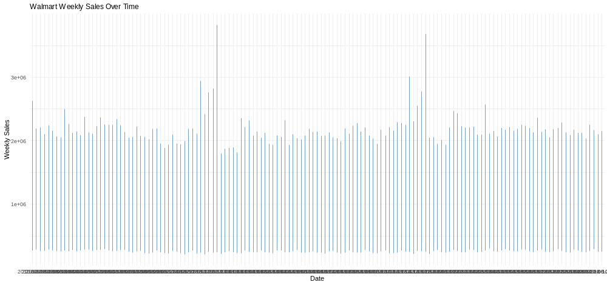

> avg_sales2 <- walmart2 %>%
+ group_by(Store) %>%
+ summarise(Average_Sales = mean(Weekly_Sales)) %>%
+ arrange(desc(Average_Sales))
> avg_sales2
# A tibble: 45 × 2
Store Average_Sales
<int> <dbl>
1 20 2107677.
2 4 2094713.
3 14 2020978.
4 13 2003620.
5 2 1925751.
6 10 1899425.
7 27 1775216.
8 6 1564728.
9 1 1555264.
10 39 1450668.
# ℹ 35 more rows
# ℹ Use `print(n = ...)` to see more rows
> ggplot(avg_sales, aes(x = reorder(as.factor(Store), -Average_Sales), y = Average_Sales)) +
+ geom_bar(stat = "identity", fill = "darkgreen") +
+ labs(title = "Average Weekly Sales by Store",
+ x = "Store", y = "Average Weekly Sales") +
+ theme_minimal()

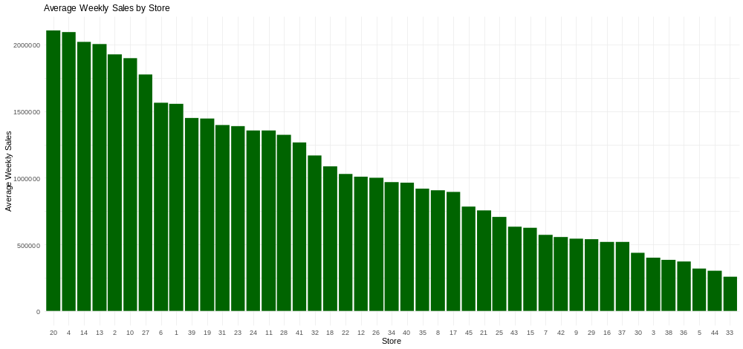

ggplot(walmart2, aes(x = as.factor(Holiday_Flag), y = Weekly_Sales)) +
+ geom_boxplot(fill = c("lightblue", "orange")) +
+ labs(title = "Weekly Sales: Holiday vs Non-Holiday Weeks",
+ x = "Holiday (0 = No, 1 = Yes)", y = "Weekly Sales") +
+ theme_minimal()

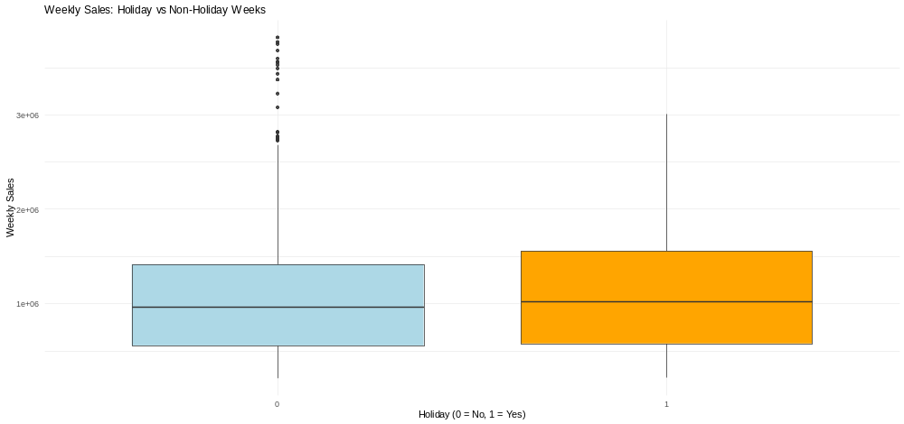

ggplot(walmart2, aes(x = Fuel_Price, y = Weekly_Sales)) +
+ geom_point(color = "tomato", alpha = 0.6) +
+ geom_smooth(method = "lm", se = FALSE, color = "black") +
+ labs(title = "Weekly Sales vs Fuel Price",
+ x = "Fuel Price", y = "Weekly Sales") +
+ theme_minimal()

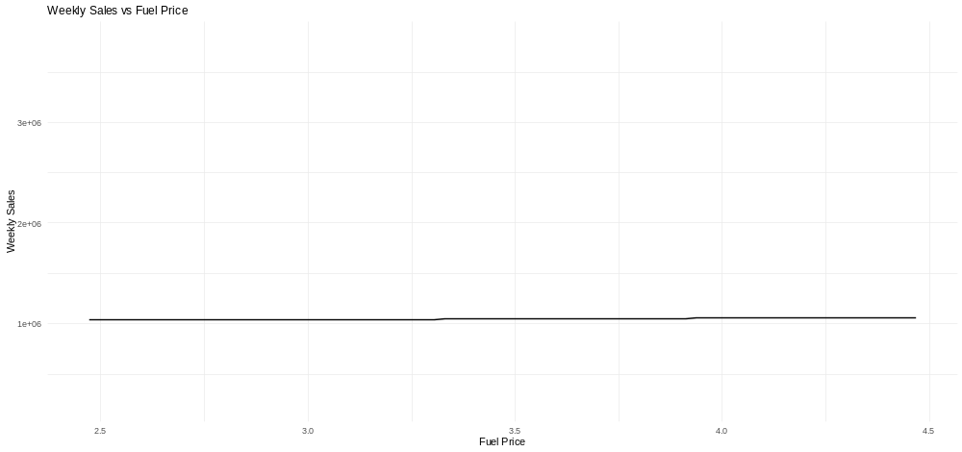

> cor_data <- walmart2 %>%select(Weekly_Sales, Temperature, Fuel_Price, CPI, Unemployment)
> cor_matrix <- cor(cor_data)
> print(round(cor_matrix, 2))
Weekly_Sales Temperature Fuel_Price CPI Unemployment
Weekly_Sales 1.00 -0.06 0.01 -0.07 -0.11
Temperature -0.06 1.00 0.14 0.18 0.10
Fuel_Price 0.01 0.14 1.00 -0.17 -0.03
CPI -0.07 0.18 -0.17 1.00 -0.30
Unemployment -0.11 0.10 -0.03 -0.30 1.00
> install.packages("corrplot")

> library(corrplot)
corrplot 0.95 loaded
Warning message:
package ‘corrplot’ was built under R version 4.4.3
> corrplot(cor_matrix, method = "circle", type = "upper", tl.cex = 0.9, tl.col = "black", col = colorRampPalette(c("red", "white", "blue"))(200))

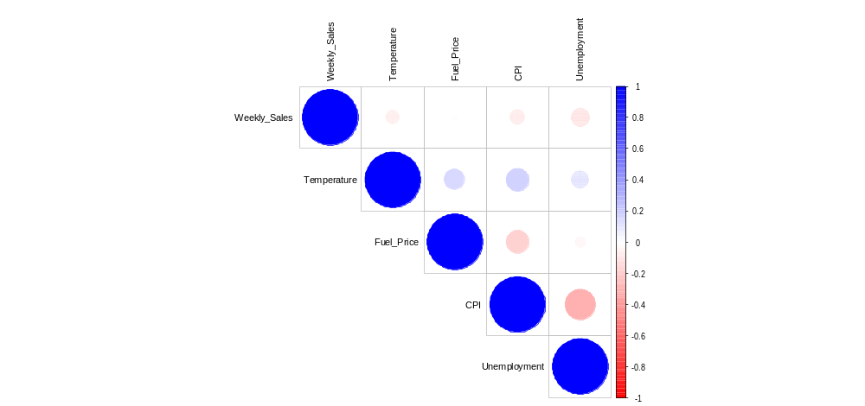

> #Regression
> model <- lm(Weekly_Sales ~ Temperature + Fuel_Price + CPI + Unemployment, data = walmart2)
> summary(model)

Call:
lm(formula = Weekly_Sales ~ Temperature + Fuel_Price + CPI +
Unemployment, data = walmart2)

Residuals:
Min 1Q Median 3Q Max
-956788 -478860 -115969 394736 2789686

Coefficients:
Estimate Std. Error t value Pr(>|t|)
(Intercept) 1743607.6 79553.1 21.918 < 2e-16 ***
Temperature -885.7 396.2 -2.235 0.0254 *
Fuel_Price -12248.4 15751.8 -0.778 0.4368
CPI -1585.8 195.2 -8.126 5.3e-16 ***
Unemployment -41215.0 3972.7 -10.375 < 2e-16 ***
---
Signif. codes: 0 ‘***’ 0.001 ‘**’ 0.01 ‘*’ 0.05 ‘.’ 0.1 ‘ ’ 1

Residual standard error: 557600 on 6430 degrees of freedom
Multiple R-squared: 0.02433, Adjusted R-squared: 0.02372
F-statistic: 40.09 on 4 and 6430 DF, p-value: < 2.2e-16

> par(mfrow = c(2, 2))
> plot(model)
>
